COAL Project Report
BCS-III(A)
Group Member
Amina Malik fa24b1-cs-051
Roma Hassan fa24b1-cs-009
Rida Gul fa24b1-cs-085

Project Name: Guess the Number Game

Assembly Language Project (EMU8086)

1. Introduction:
This project is based on Assembly Language (Intel 8086) and demonstrates a simple Guess the Number Game using a Command Line User Interface (CLI). The game allows a user to guess a number, receive feedback, and continue guessing until the correct number is entered. The project is designed for beginners to understand core assembly language concepts.

2. Project Objectives:
- To understand basic Assembly Language syntax
- To learn input/output operations using DOS interrupts
- To use conditional statements and loops
- To understand comparison operations
- To implement a simple game logic in CLI environment

3. Tools and Software Used:
- Software: EMU8086
- Processor: Intel 8086
- Interface: Command Line User Interface (CLI)
- Language: Assembly Language

4. Project Description:
The Guess the Number Game works as follows:
- The program asks the user to guess a number between 0 and 9.
- The user enters a single digit using the keyboard.
- The program compares the guessed number with a secret number.
- Feedback is displayed:
Too High if the guess is greater
Too Low if the guess is smaller
Correct Guess if the guess is right
- The game continues until the correct number is guessed.

5. Version 1: Simple Guess the Number Game (Without Innovation)

Description:
In this version, the secret number is fixed. The program continuously asks the user to guess the number until the correct value is entered.

Features:
- Fixed secret number
- Single character input
- Loop-based guessing
- Simple comparison logic

Source Code (Without Innovation):
.MODEL SMALL
.STACK 100h

.DATA
PROMPT_MSG DB "Guess a number between 0 and 9: $"
TOO_HIGH_MSG DB 0Ah, 0Dh, "Too high, try again.$"
TOO_LOW_MSG DB 0Ah, 0Dh, "Too low, try again.$"
WIN_MSG DB 0Ah, 0Dh, "Congratulations - You have won the game!$"

SECRET_NUM DB '5'
GUESS_CHAR DB ?

.CODE
MAIN PROC FAR
MOV AX, @DATA
MOV DS, AX

MOV AH, 9
MOV DX, OFFSET PROMPT_MSG
INT 21h

GUESS_LOOP:
MOV AH, 1
INT 21h
MOV GUESS_CHAR, AL

CMP AL, SECRET_NUM
JE GUESSED_CORRECTLY
JG GUESS_TOO_HIGH
JL GUESS_TOO_LOW

GUESS_TOO_HIGH:
MOV AH, 9
MOV DX, OFFSET TOO_HIGH_MSG
INT 21h
JMP GUESS_LOOP

GUESS_TOO_LOW:
MOV AH, 9
MOV DX, OFFSET TOO_LOW_MSG
INT 21h
JMP GUESS_LOOP

GUESSED_CORRECTLY:
MOV AH, 9
MOV DX, OFFSET WIN_MSG
INT 21h

MOV AH, 4Ch
INT 21h

MAIN ENDP
END MAIN

Output:
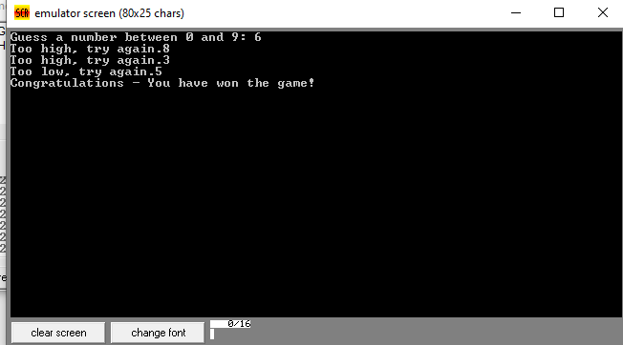

6. Version 2: Enhanced Guess the Number Game (With Innovation)

Description:
This version improves the game by adding random number generation, attempt counter, and play again option. This makes the game more interactive and user-friendly.

Innovative Features:
- Random secret number (0–9)
- Attempt counter
- Replay option (Y/N)
- Improved user interaction

Source Code (With Innovation):
.MODEL SMALL
.STACK 100h

.DATA
PROMPT_MSG DB 13,10,"Guess a number between 0 and 9: $"
TOO_HIGH_MSG DB 13,10,"Too high, try again.$"
TOO_LOW_MSG DB 13,10,"Too low, try again.$"
WIN_MSG DB 13,10,"Congratulations! You won.$"
TRY_MSG DB 13,10,"Attempts: $"
AGAIN_MSG DB 13,10,"Play again? (Y/N): $"

SECRET_NUM DB ?
GUESS_CHAR DB ?
ATTEMPTS DB 0

.CODE
MAIN PROC FAR
MOV AX, @DATA
MOV DS, AX

START_GAME:
MOV ATTEMPTS, 0

MOV AH, 2Ch
INT 21h
MOV AL, DL
AND AL, 09h
ADD AL, '0'
MOV SECRET_NUM, AL

MOV AH, 9
MOV DX, OFFSET PROMPT_MSG
INT 21h

GUESS_LOOP:
MOV AH, 1
INT 21h
MOV GUESS_CHAR, AL

INC ATTEMPTS

CMP AL, SECRET_NUM
JE GUESSED_CORRECTLY
JG TOO_HIGH
JL TOO_LOW

TOO_HIGH:
MOV AH, 9
MOV DX, OFFSET TOO_HIGH_MSG
INT 21h
JMP GUESS_LOOP

TOO_LOW:
MOV AH, 9
MOV DX, OFFSET TOO_LOW_MSG
INT 21h
JMP GUESS_LOOP

GUESSED_CORRECTLY:
MOV AH, 9
MOV DX, OFFSET WIN_MSG
INT 21h

MOV AH, 9
MOV DX, OFFSET TRY_MSG
INT 21h

MOV AL, ATTEMPTS
ADD AL, '0'
MOV DL, AL
MOV AH, 2
INT 21h

MOV AH, 9
MOV DX, OFFSET AGAIN_MSG
INT 21h

MOV AH, 1
INT 21h
CMP AL, 'Y'
JE START_GAME
CMP AL, 'y'
JE START_GAME

MOV AH, 4Ch
INT 21h

MAIN ENDP
END MAIN

Output:

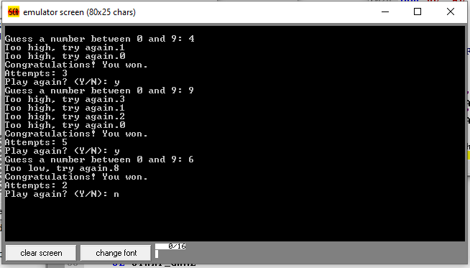

7. Comparison of Both Versions:
Feature | Without Innovation | With Innovation
Secret Number | Fixed | Random
Attempt Counter | No | Yes
Replay Option | No | Yes
User Interaction | Basic | Enhanced

8. Learning Outcomes:
- Understanding of Assembly Language structure
- Use of DOS interrupts for input/output
- Implementation of loops and conditional jumps
- Working with registers and memory variables
- Basic game logic development

7A. Working Principle of the Assigned / Proposed Project

Working Principle:
The Guess the Number Game works on a simple comparison-based logic using Assembly Language (8086). The working principle is explained step by step below:
1. Program Initialization
When the program starts, the data segment is initialized using the DS register. All messages and variables are loaded into memory.
2. Secret Number Selection
In the simple version, the secret number is predefined (fixed value).
In the innovative version, the program generates a random number (0–9) using system time via DOS interrupt INT 21h (AH = 2Ch).
- User Input
The user enters a single digit through the keyboard. The input is taken using DOS interrupt INT 21h (AH = 01h) and stored in a variable.

- Comparison Logic
The entered number is compared with the secret number using the CMP instruction.
If the guessed number is greater → "Too High" message is displayed.
If the guessed number is smaller → "Too Low" message is displayed.
If both numbers are equal → User wins the game.
- Loop Execution:
The program uses a loop to repeatedly ask the user for input until the correct number is guessed.

- Additional Features (Innovative Version)
The program counts the number of attempts.
After winning, the user is asked whether they want to play again.
- Program Termination
The program ends gracefully using INT 21h (AH = 4Ch).

7B. Block Diagram of the Project

Block Diagram Description
Since this is a command-line-based assembly program, the block diagram represents the logical flow of the game:
+-------------------+
| Start Program |
+-------------------+
|
v
+-------------------+
| Initialize Data |
+-------------------+
|
v
+-------------------+
| Generate / Set |
| Secret Number |
+-------------------+
|
v
+-------------------+
| Take User Input |
+-------------------+
|
v
+-------------------+
| Compare Numbers |
+-------------------+
| | |
| | |
v v v
Too Low Too High Correct
| | |
+--------+ v
| Display Result
| |
+------------+
|
v
End Program / Play Again

7C. Input and Output of the Project

Inputs:
The inputs of the project are:
- User Guess:
- A single digit number (0–9)
- Entered through keyboard
- Taken using DOS interrupt INT 21h
- System Time (Innovative Version):
- Used to generate a random secret number

Outputs:
The outputs of the project are:
- Text Messages displayed on screen:
- "Guess a number between 0 and 9"
- "Too High, try again"
- "Too Low, try again"
- "Congratulations! You won"
- Attempt Count (Innovative Version)
- Play Again Prompt (Y/N)

Input–Output Differentiation Table:
Category | Description
Input | User enters a number (0–9) via keyboard
Input | System time used for random number generation
Output | Game messages shown on screen
Output | Winning message and attempt count

9. Group Members Roles and Contribution Summary:
This project was completed as a group of three members. Each member had a clearly defined role and contributed equally to the successful completion of the project.
Group Member | Role | Contribution Summary
Member 1 | Team Leader | Planned the project, divided tasks among members, supervised progress, and reviewed the final implementation and report.
Member 2 | Programmer | Developed the Assembly Language source code, implemented game logic, handled input/output operations, and tested the program in EMU8086.
Member 3 | Documentation & Design | Prepared the complete project report, explained the working principle, designed the block diagram, documented input/output details, and assisted in debugging.
All group members actively participated in discussions, idea sharing, testing, and final verification of the project

10. Conclusion:
This project successfully demonstrates how a simple game can be implemented in Assembly Language using EMU8086. The enhanced version shows how innovation can improve functionality and user experience. This project strengthens the understanding of low-level programming concepts and logical thinking.

11. References:
EMU8086 Official Documentation
Intel 8086 Architecture Notes
Assembly Language Course Notes
.

